Practical - 2
Practical Title: Semantic HTML5 Pages with Accessibility-Ready Structure

Develop static HTML5 skeletons for at least 10 StudentHub pages such as Home, About, Register, Login, Dashboard, Events, Profile, Contact, Admin, FAQ, and Feedback. Use semantic tags and accessibility-friendly structure.

Theory
1. Are semantic tags such as header, nav, main, section, article, aside, and footer used properly?
No. In the provided HTML code, semantic tags such as <header>, <nav>, <main>, <section>, <article>, <aside>, and <footer> are not used properly. Most of the page structure is created using <div>, <table>, <h1>–<h4>, and <p> tags. For example, the navigation links could be placed inside <nav>, the main page content inside <main>, related side content inside <aside>, and bottom links such as FAQ, Feedback, and About inside <footer>. Therefore, the pages work, but they could be improved by using semantic HTML tags for better structure, accessibility, and readability.
2. Are form labels, headings, image alt text, and navigation links accessible?
Partially. The headings and navigation links are generally accessible because clear headings such as <h1>, <h2>, and <h3> are used, and navigation is provided through <a> links. The image has an alt attribute (alt="Login"), which is good for accessibility. However, the form labels are not fully accessible because some <input> elements do not have properly associated <label> elements using matching for and id attributes. Therefore, the website has some accessibility features, but the forms should be improved by properly connecting labels with their input fields.
3. Is the page structure consistent across all pages?
Yes, the page structure is mostly consistent across all pages. Most pages use a similar layout with headings, horizontal lines, content sections, navigation links, and footer links such as FAQ, Feedback, and About. The pages also use external CSS files for styling. However, the structure is not completely consistent because some pages use tables for layout, while others use forms, lists, or simple paragraphs, and semantic HTML elements such as <header>, <nav>, <main>, and <footer> are not consistently used.

Implementation/ Output/Result
Tags:
<!DOCTYPE html>
<html>
<head>
<title>
<link>
<body>
<div>
<table>
<tr>
<th>
<td>
<h1>
<h2>
<h3>
<h4>
<p>
<a>
<img>
<form>
<input>
<textarea>
<select>
<option>
<label>
<button>
<br>
<hr>
<fieldset>
<strong>
<ul>
<li>
<details>
<summary>

HTML webpages screenshots:
Homepage: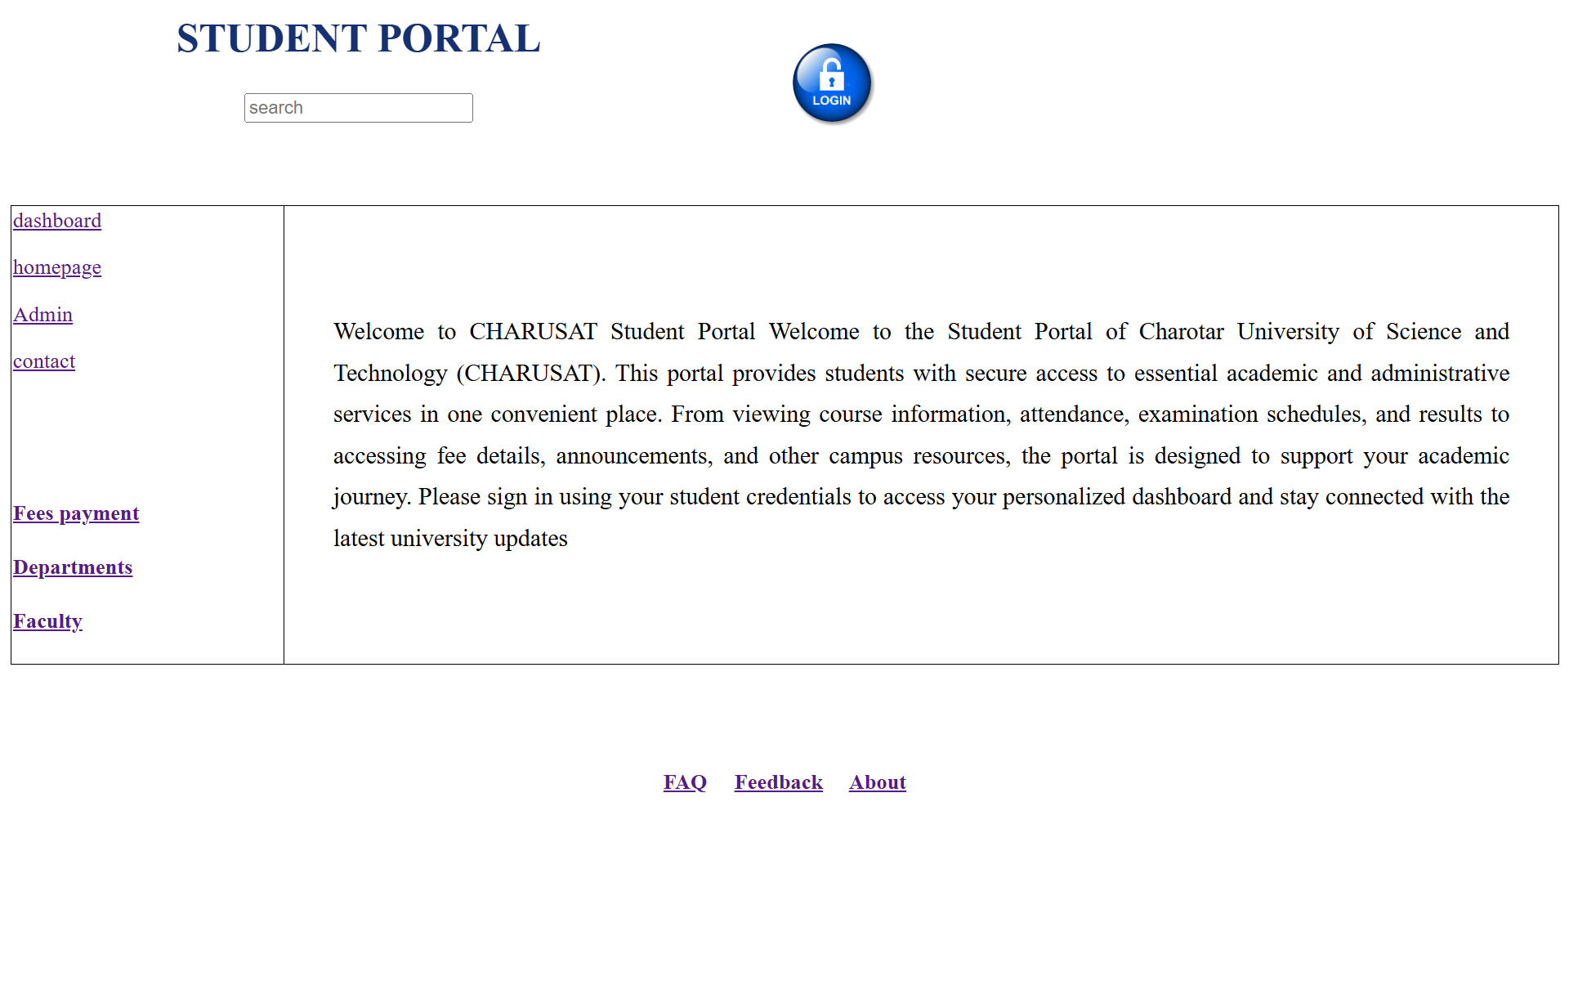

Studentdashboard:
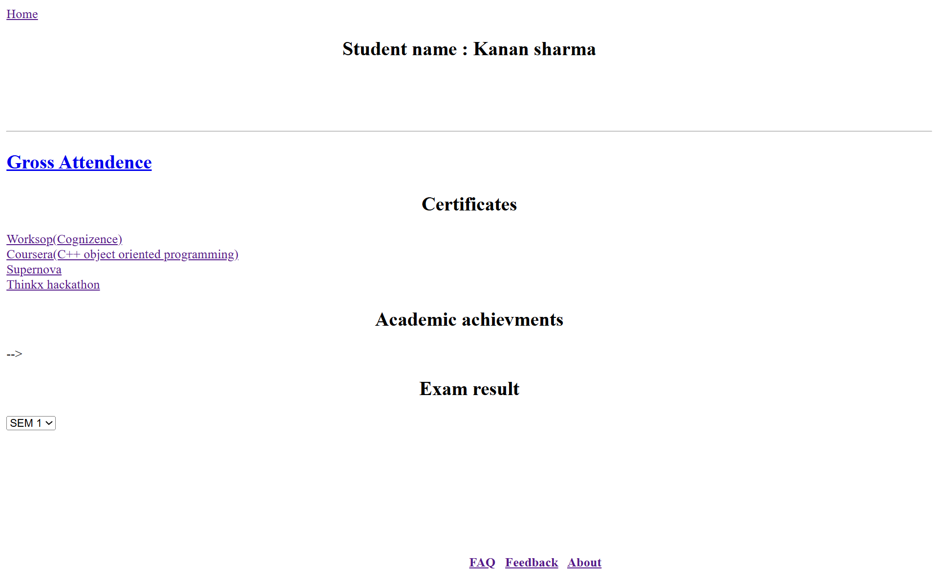

Admin:
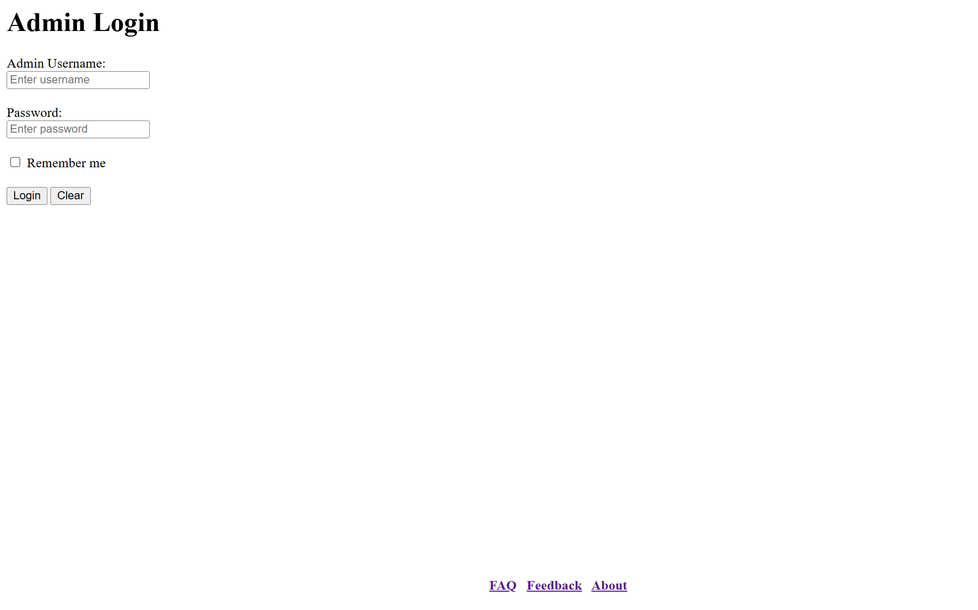

Contact us:
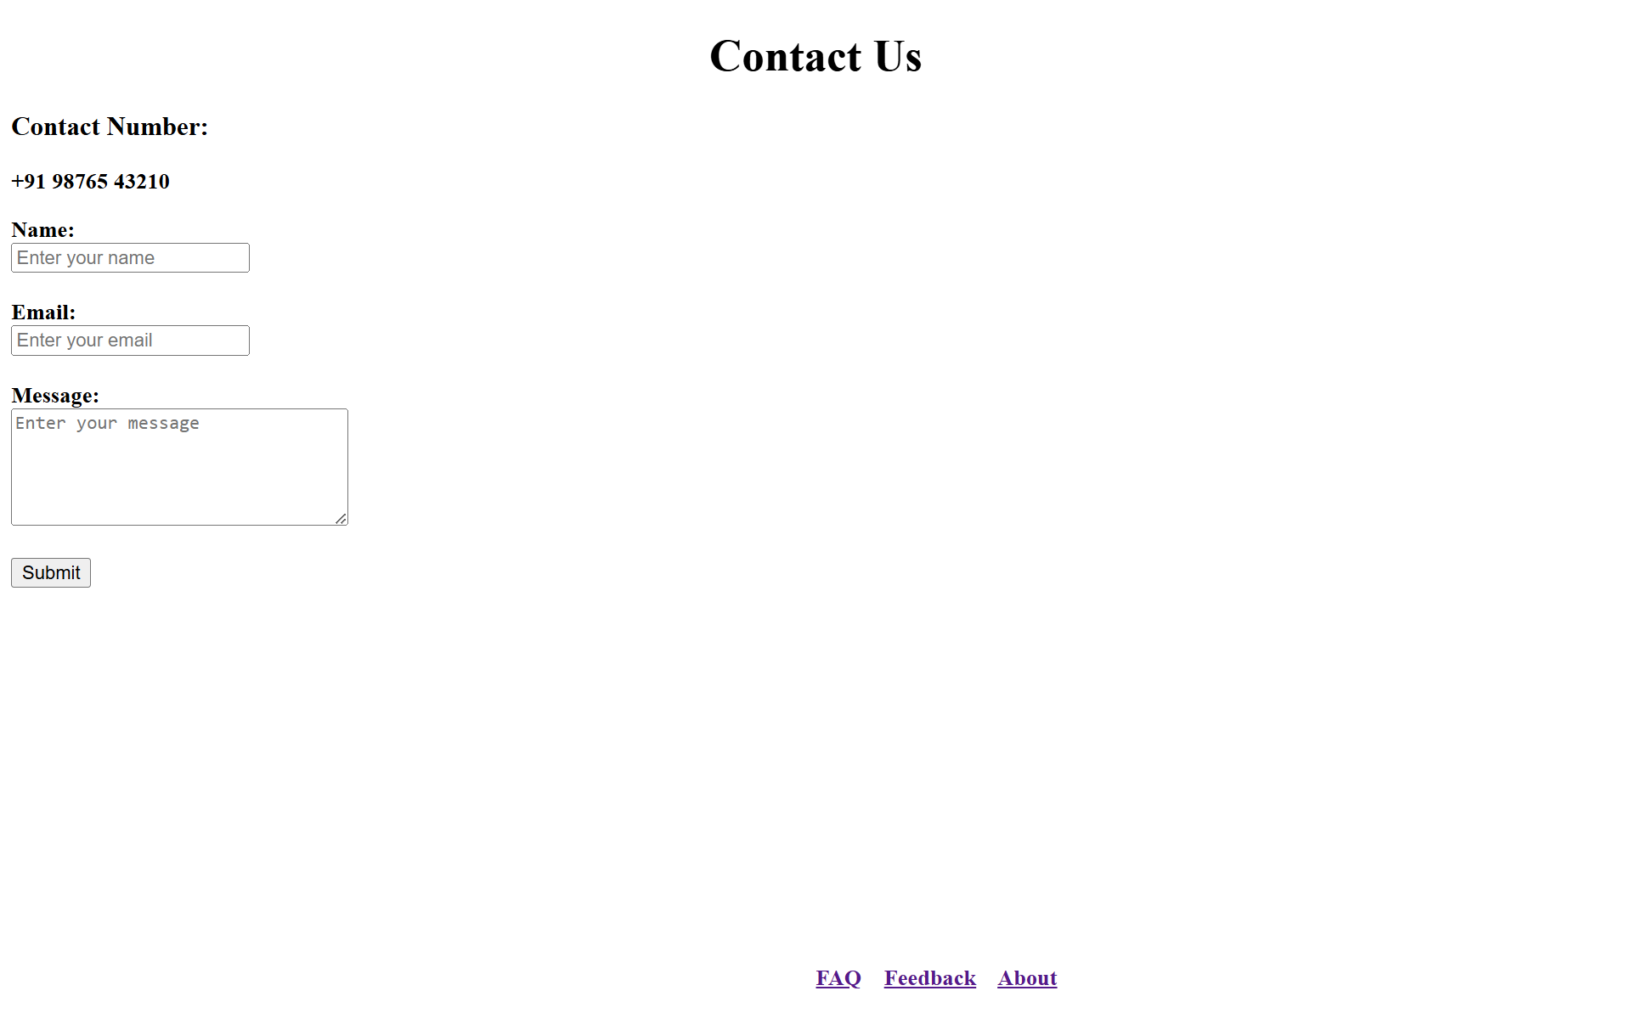

Fee payment gateway:
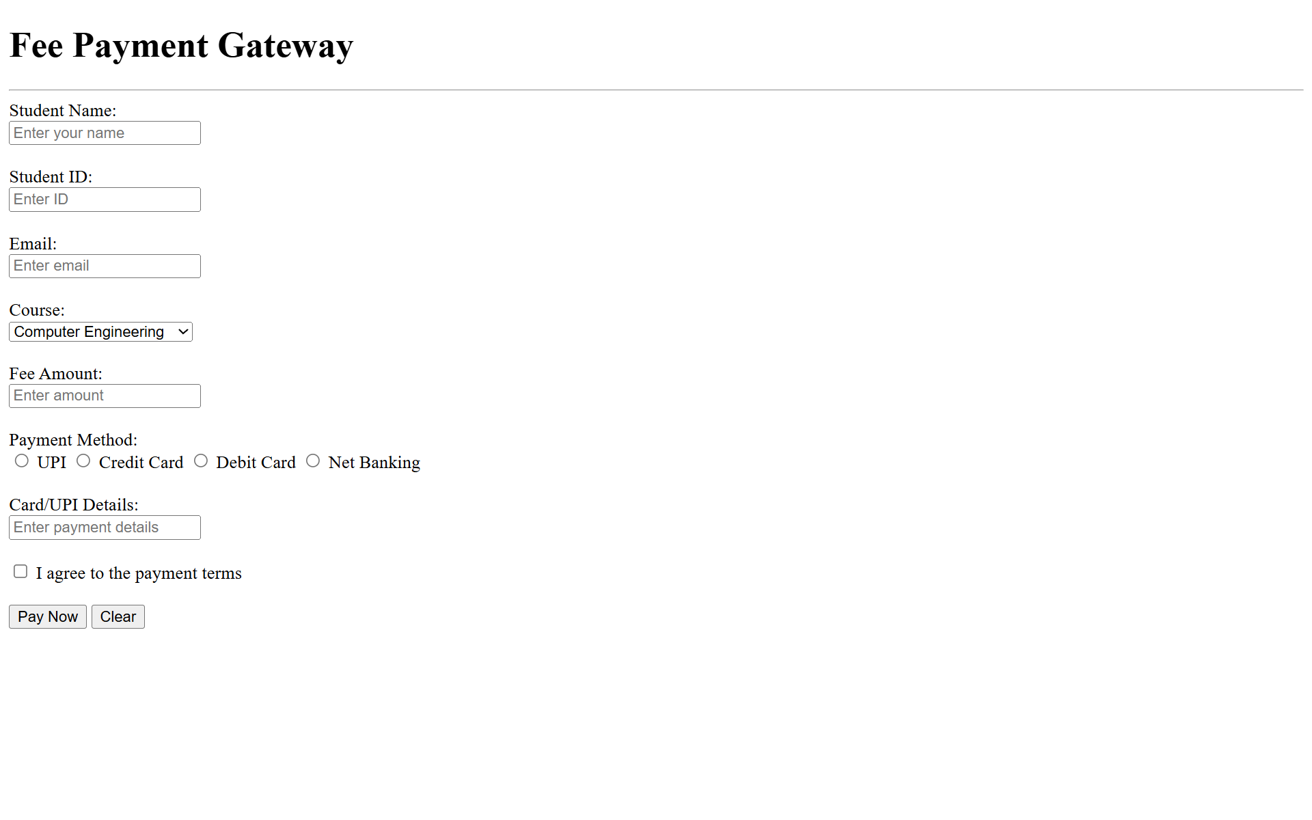

Departments:
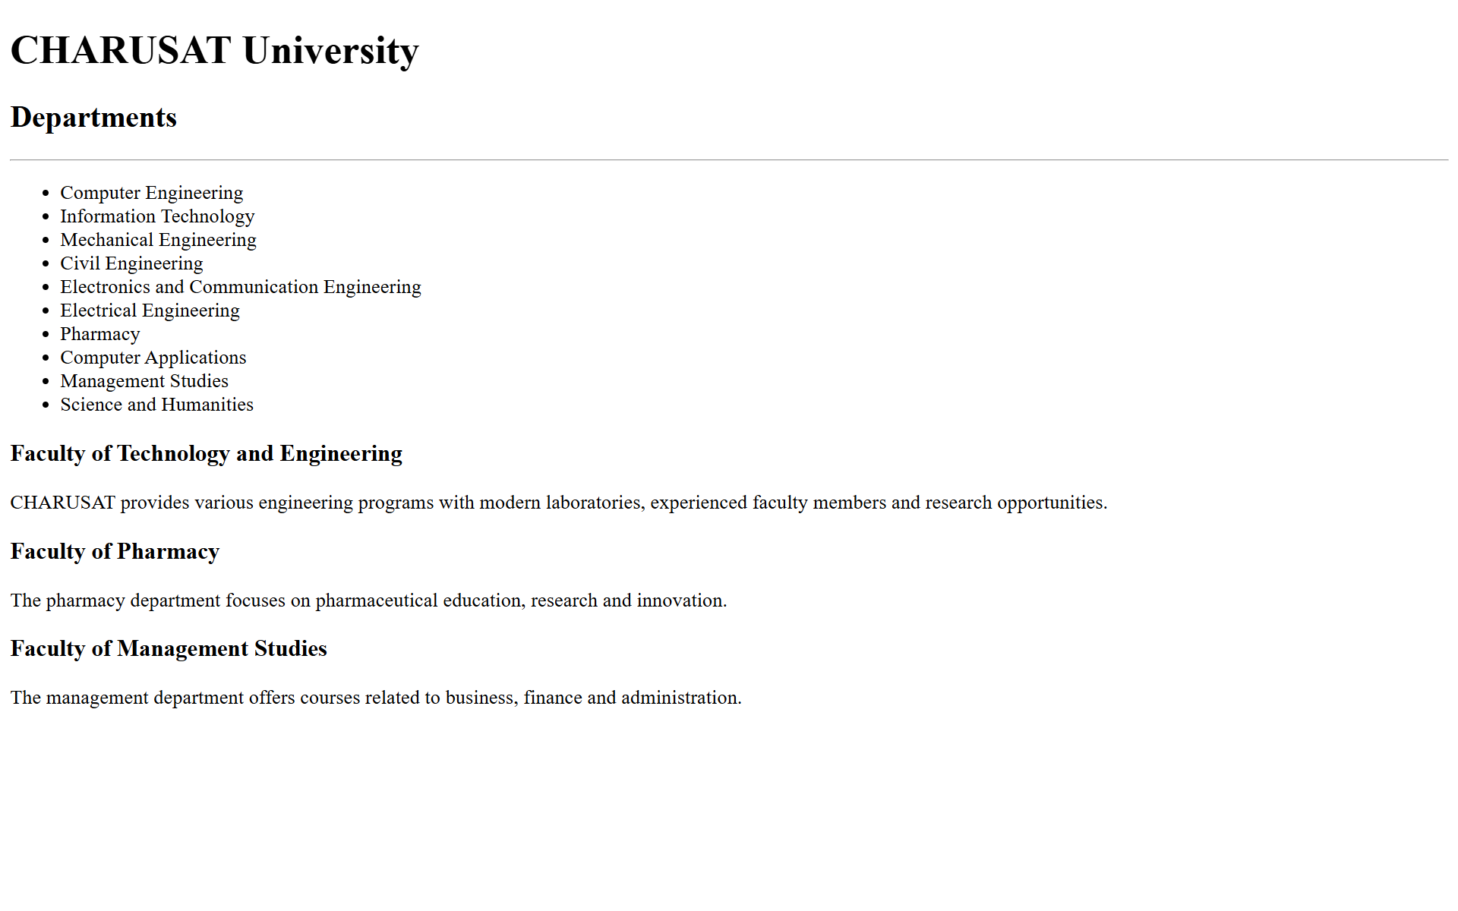

Faculty:
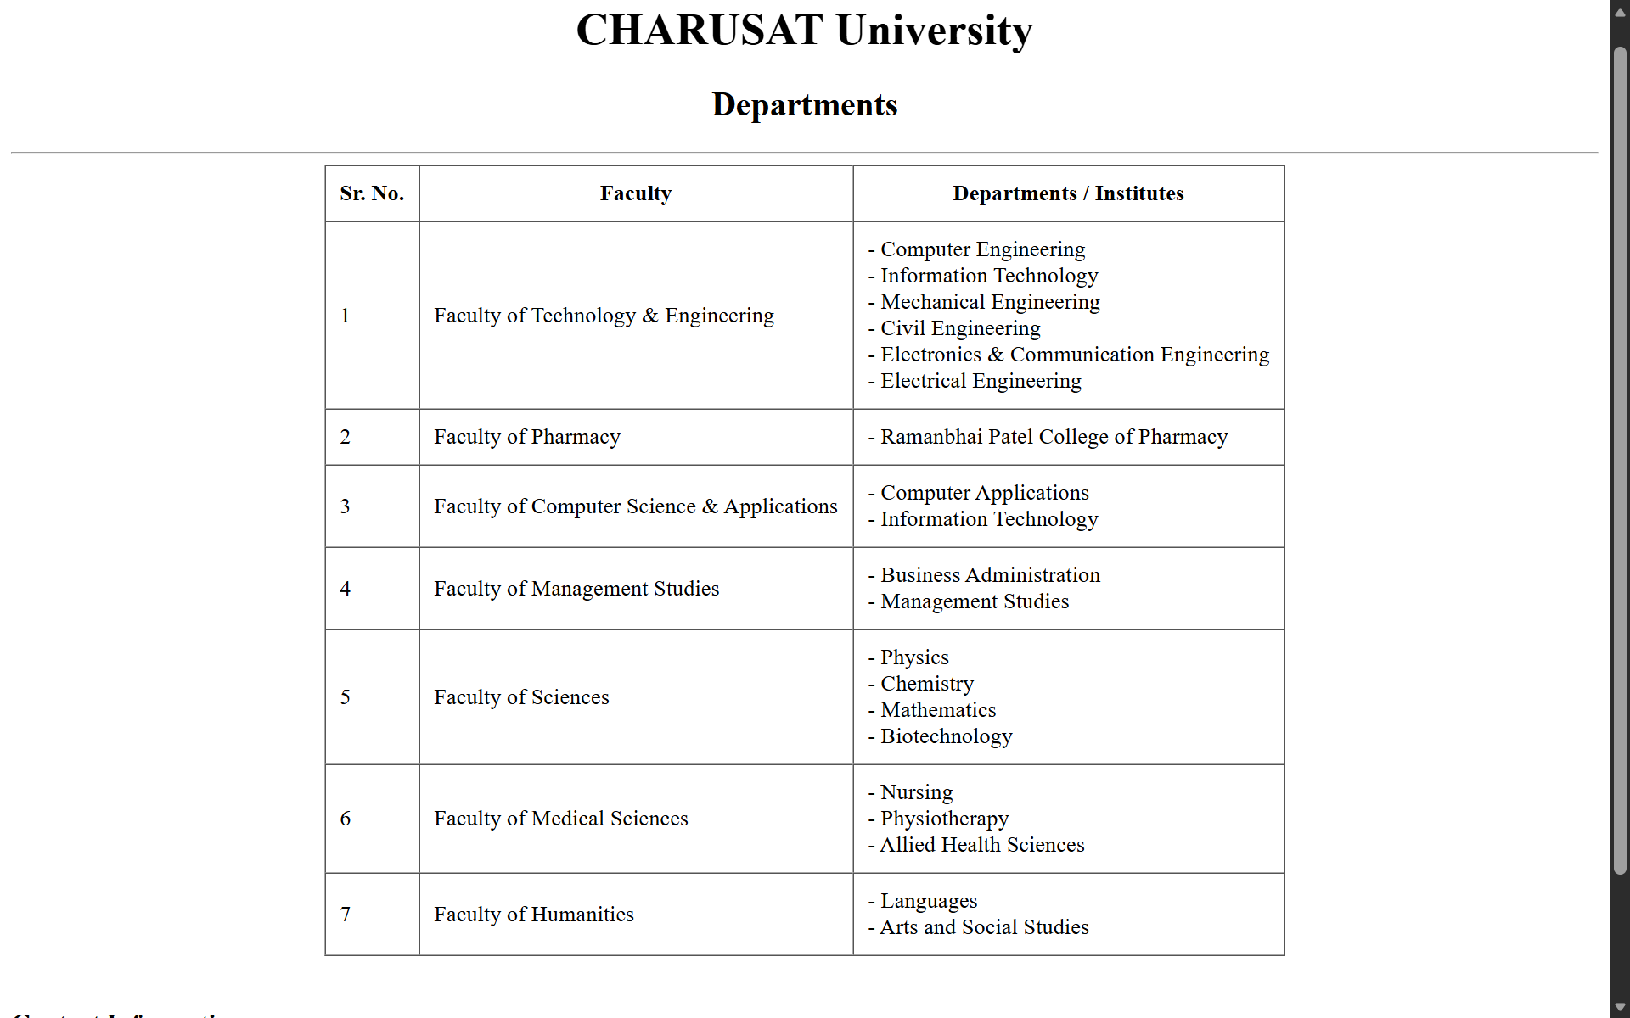

FAQ
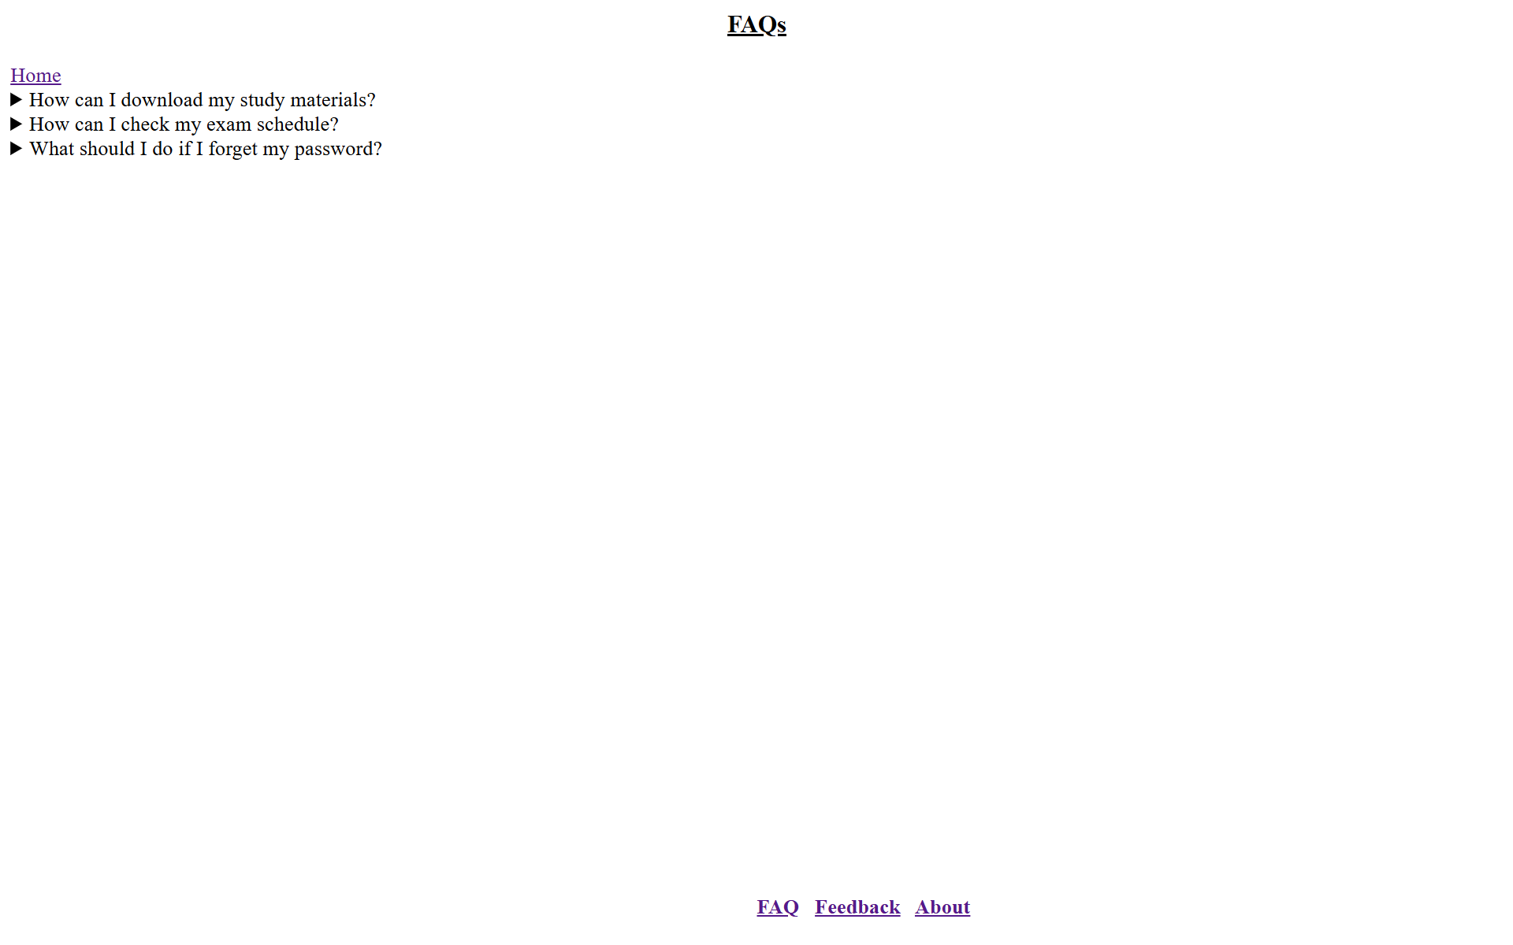

Feedback:
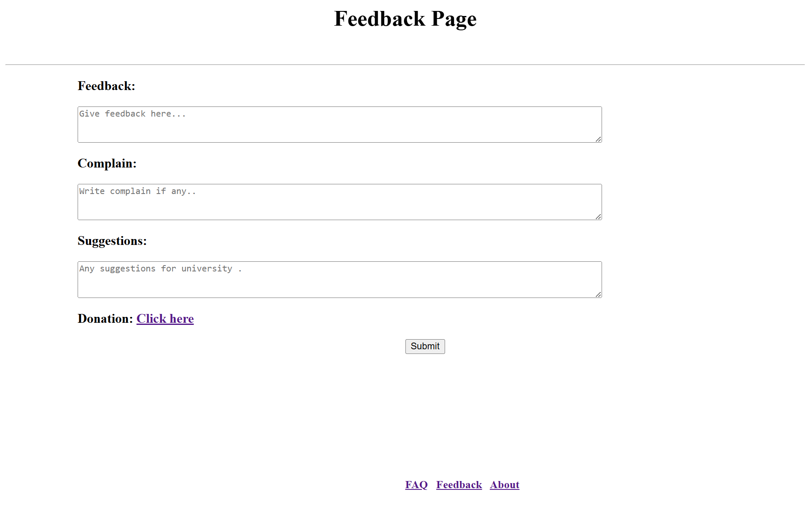

About:
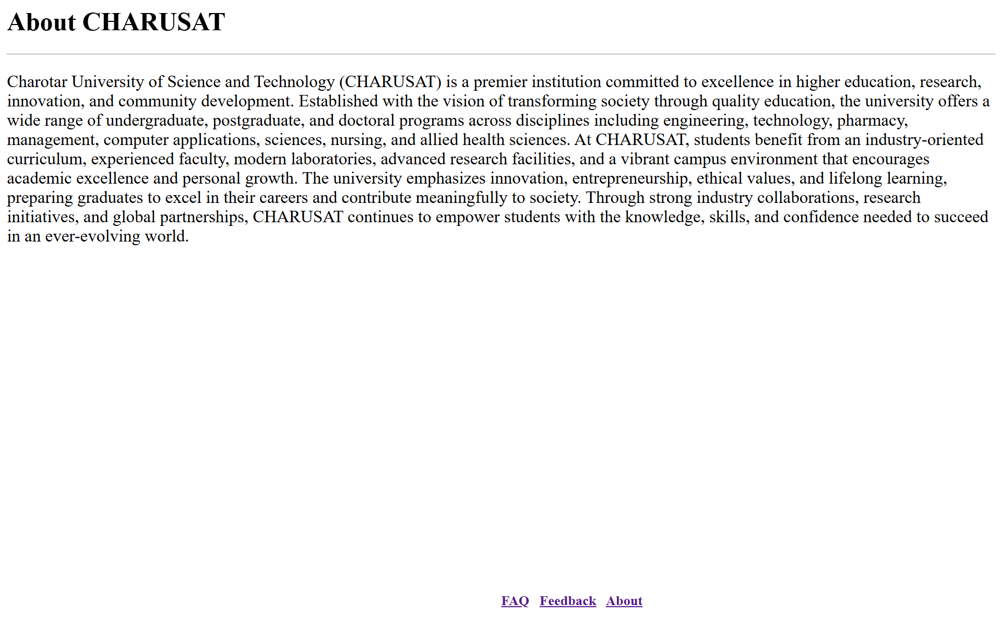

GitHub Repository Link:

https://github.com/kanan2007s-sys/Web-development-/tree/main

Challenges Faced:

The main challenge was to use the correct HTML tag and implement it. I couldn’t find the html tags and sometimes not get the attribute to be used.

Learning Outcomes:
I learned how to use HTML tags and their attributes to create a website.

Faculty Remarks:

